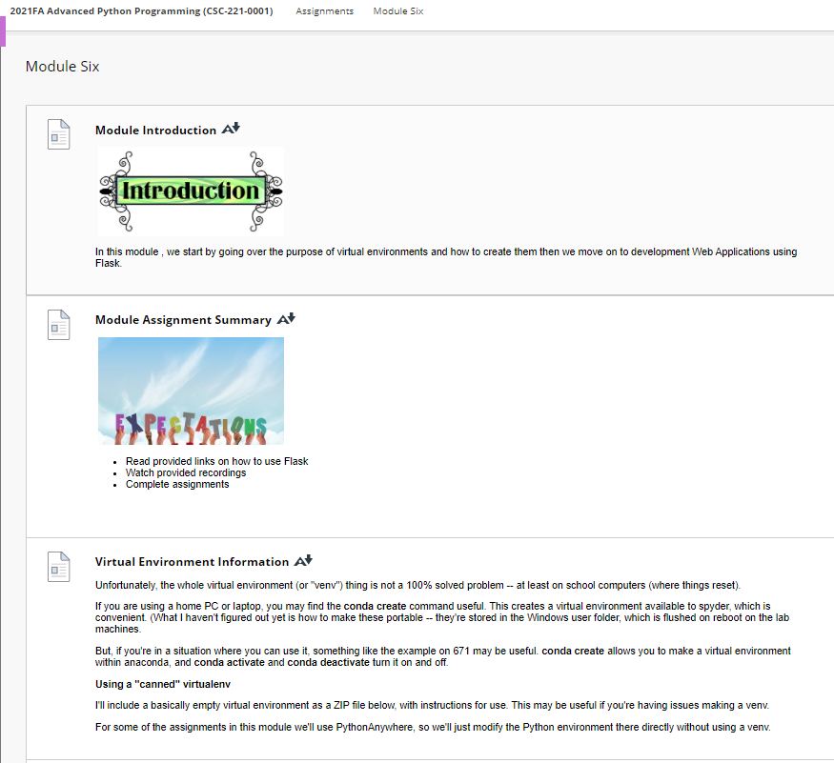

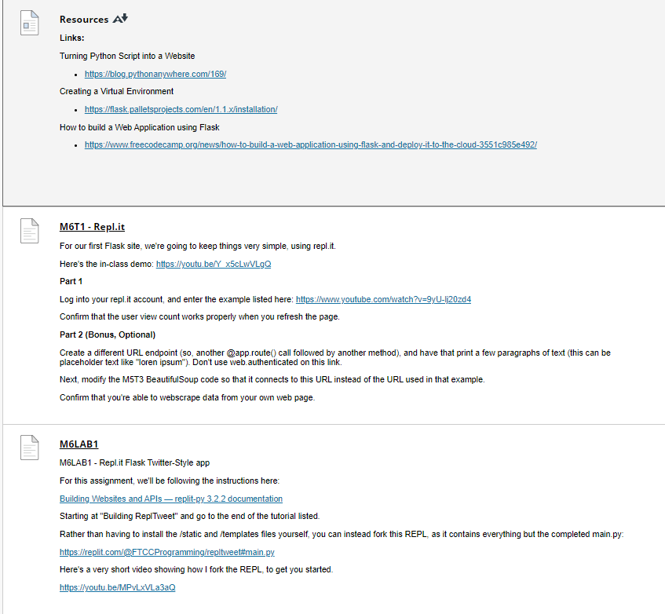

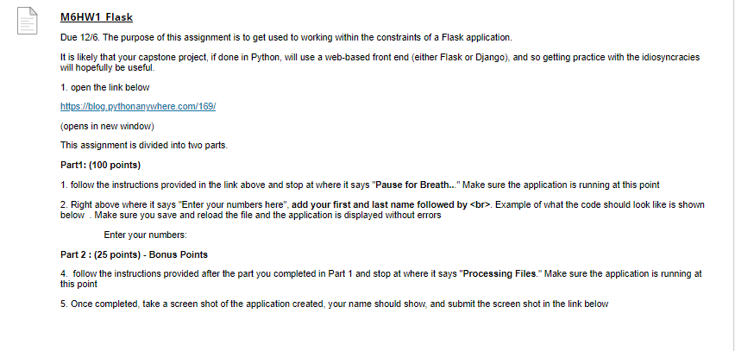

**Virtual Environment Information**

[Virtual Environment Information](https://faytechcc.blackboard.com/webapps/blackboard/content/listContent.jsp?course_id=_35059_1&content_id=_5950157_1)

Unfortunately, the whole virtual environment (or "venv") thing is not a 100% solved problem -- at least on school computers (where things reset).

If you are using a home PC or laptop, you may find the **conda create** command useful. This creates a virtual environment available to spyder, which is convenient. (What I haven't figured out yet is how to make these portable -- they're stored in the Windows user folder, which is flushed on reboot on the lab machines.

But, if you're in a situation where you can use it, something like the example on 671 may be useful. **conda create** allows you to make a virtual environment within anaconda, and **conda activate** and **conda deactivate** turn it on and off.

**Using a "canned" virtualenv**

I'll include a basically empty virtual environment as a ZIP file below, with instructions for use. This may be useful if you're having issues making a venv.

For some of the assignments in this module we'll use PythonAnywhere, so we'll just modify the Python environment there directly without using a venv.

[Resources](https://faytechcc.blackboard.com/webapps/blackboard/content/listContent.jsp?course_id=_35059_1&content_id=_5950157_1)

**Links:**

Turning Python Script into a Website

* <https://blog.pythonanywhere.com/169/>

Creating a Virtual Environment

* <https://flask.palletsprojects.com/en/1.1.x/installation/>

How to build a Web Application using Flask

* <https://www.freecodecamp.org/news/how-to-build-a-web-application-using-flask-and-deploy-it-to-the-cloud-3551c985e492/>